Dinner Meeting- August 17th:
Our picnic will be at 6 pm at Plymouth Twp Park at the pavilion on the left at the top of the hill. This month you do not have to bring your dinner. At the meeting, we decided to order sandwiches from the Anatasia & Kathie’s Coffee Shop to support them. If you didn’t give Kathy your choice, please call her. Kathy will also purchase chips and cookies for us. Bring your own beverage.

Business Meeting-September 7th:
The meeting will be at the Salvation Army building at 9451 S. Main St., Plymouth at 6:30 pm.

October Social-October 11th:
We are planning the Social Outing at the Living & Learning Enrichment Center in Northville for October 11th. Mark your calendars. More information to come.

Projects

Charity Poker -August 10-13:
The schedule is on the Club website if you need to confirm your shift times.

Michigan Area Lotto Raffle Tickets:
Good luck!! The raffle drawing is daily during the month of September.

Plymouth Fall Festival- September 8-10
The festival hours are: Friday 9/8 & Saturday 9/9 noon-10 pm and Sunday 9/10 noon-6 pm. We will have our photo booth & hope to assist with the snow cone truck for which we will earn money based on sales. If you haven’t signed up for a shift to work contact Cheryl.

Volunteers setting up the booth on Thursday 9/7 will meet at 3 pm in Kellogg Park.

The afterglow party will be held at 6 pm on Sunday 9/10 at Hal and Cheryl’s home at 1576 Walnut Ridge Circle, Canton 48187. There will be pizza and adult beverages. All members are invited to the afterglow.

Down Syndrome Walk September 24th:
The Walk will be Noon-6 pm at the Clawson City Park at 939 N. Custer Ave, Clawson 48017. We will handle registration and sell
t-shirts. Mary needs 6-8 volunteers.

Ford Road Clean-Up-September 27th:
We will meet in the office Max parking lot at 9 am. Breakfast to follow.

Operation Good Cheer:
If you would like to adopt a foster child for Christmas, let Cheryl know by September 8th so we can reserve the children. Ask friends and family to participate. The children’s wish list will arrive mid-October. Gifts will be due to Cheryl by November 27th.

Focus Hope October 14th:
We will meet in the Costco parking lot at Middlebelt and the I96 service drive. We are meeting at 8:30 am. Park on the service drive side. We will pack food boxes from 9 am-12 pm followed by a group lunch. Let Gary know if you plan to attend.

KVCC Collecting Stuffed Animals:
KVCC is collecting small and medium sized gently used stuffed animals to be used as game prizes for their Pumpkin Fest. If you or friends have any to donate please give them to Maureen, Theresa or Hal.

Desert Angels
The Kensington Valley Civitans are collecting donations for the Miracle Boxes (care packages) for active service personnel stationed overseas. If you have items to donate, you can give them to Maureen, Theresa or Hal. All members are invited to pack the boxes on November 16th in South Lyon. The list of desired items is below. Ask friends and family to participate.

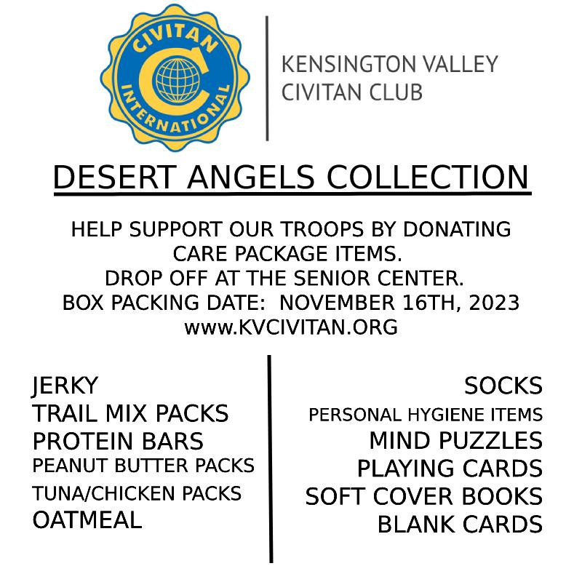
Donations:

The Club donated $1300 to the Walk and Roll event at the International Convention which benefits the CIRC. Hal and Cheryl are participating in the Walk resulting in a total donation of $1,500 to CIRC.

Birthdays:
Ellen Garner 9/17
Mary Stewart 9/17
Daphne Richards 9/29

Calendar

8/10-13 Charity Poker
8/17 Picnic
9/7 Business Meeting Salvation Army
9/8-10 Plymouth Fall Festival
9/21 Dinner Meeting, Location TBD
9/24 Down Syndrome Walk
9/27 Ford Rd Clean-up 9 am
10/11 Social Outing
10/14 Focus Hope
11/16 KVCC packing party

